Fisa de evaluare pentru clasa a VIII_a(Raurile Romaniei)
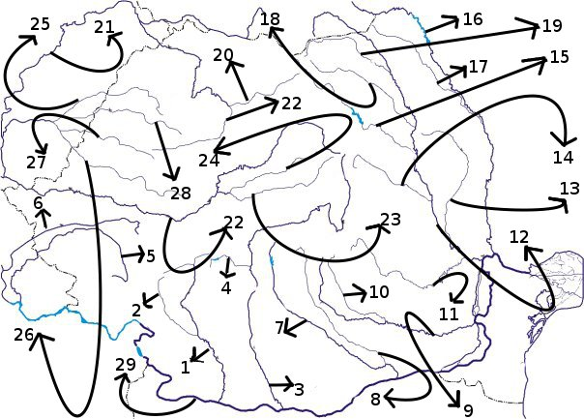
Numiti raurile numerotate cu cifre de la 1 la 29
\

1…………………………………..
2……………………………………..
3………………………………………
4……………………………………
5…………………………………….
6………………………………………
7…………………………………….
8……………………………………….
9……………………………………..
10………………………………………
11……………………………………….
12………………………………………..
13…………………………………………..
14…………………………………………….
15……………………………………………..
16…………………………………………….
17…………………………………………………
18…………………………………………………………….
19………………………………………………………
20……………………………………….
21………………………………………..
22………………………………………….
23……………………………………………
24……………………………………………..
25…………………………………………………
26……………………………………………….
27……………………………………………..
28……………………………………………….
29………………………………………………….

