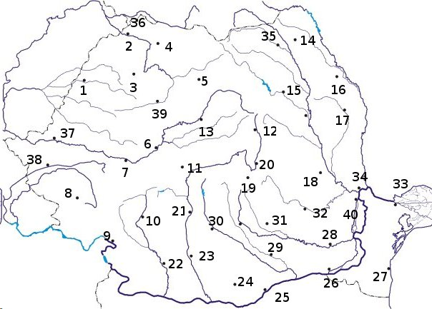

1………………………………………..
2………………………………………….
3…………………………………………
4………………………………………….
5…………………………………………..
6……………………………………………..
7……………………………………………
8………………………………………………..
9…………………………………………….
10……………………………………………
11……………………………………………..
12…………………………………………………
13……………………………………………………
14…………………………………………………….
15…………………………………………………..
16……………………………………………………
17…………………………………………………………
18…………………………………………………………..
19………………………………………………………..
20………………………………………………………..
21………………………………………………………………..
22…………………………………………………………….
23…………………………………………………………………………
24………………………………………………………………………
25…………………………………………………………………
26………………………………………………………………….
27…………………………………………………………………….
28………………………………………………………………………………….
29…………………………………………………………………………….
30……………………………………………………………………………….
31…………………………………………………………………………………..
32………………………………………………………………………………
33…………………………………………………………………………….
34……………………………………………………………………………..
35……………………………………………………………………………….
36……………………………………………………………………………….
37…………………………………………………………………………………
38……………………………………………………………………………………
39………………………………………………………………………………….
40………………………………………………………………………

