Fisa de evaluare clasa a VI-a
Folosind harta de mai jos notati numele tarilor numerotate de la 1 la 10

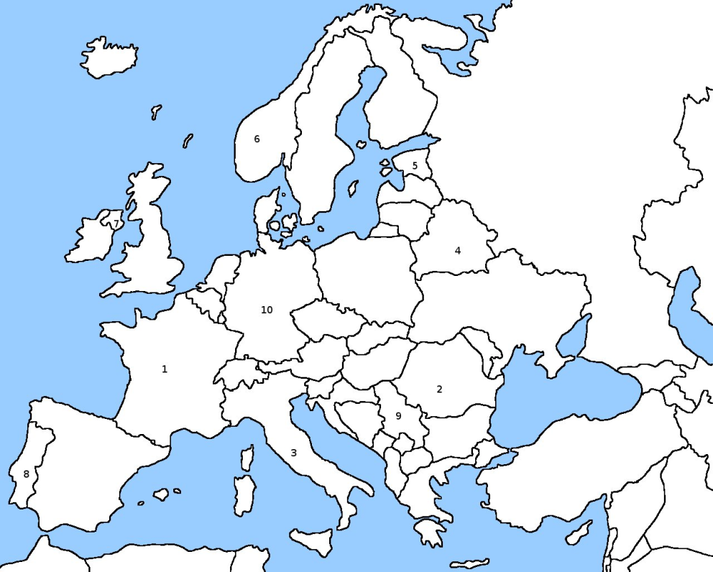

1…………………………………………………….
2…………………………………………………….
3…………………………………………………….
4…………………………………………………….
5……………………………………………………

6………………………………………………………
7………………………………………………………
8………………………………………………………
9………………………………………………………
10………………………………………………………

Timp de lucru 20 de minute

